Annuity Service Providers(ASP)
At the time of exit from NPS for reasons other than death of the subscriber, the subscriber is required to purchase an annuity providing for a monthly pension to the subscriber from an Annuity Service Provider empanelled with PFRDA. In Indian context, annuities in simple terms, are financial instruments which offer a monthly/quarterly/annual pension at a guaranteed rate for the period you choose for a given purchase price.
Annuity Service Providers are IRDA licensed and regulated Life Insurance companies, transacting annuity business in India and who are empanelled by PFRDA for servicing the annuity requirements of the NPS subscribers.
At present the following 5 ASPs are providing the Annuity services to NPS subscribers and the list of ASP’s is as follows:
1.HDFC Standard Life Insurance Co. Ltd.
2.ICICI Prudential Life Insurance Co. Ltd.,
3.LIC of India
4.SBI Life Insurance Co. Ltd.,
5.Star Union Dai-ichi Life Insurance Co. Ltd.

These ASP’s are prudentially regulated and monitored by Insurance Regulatory and Development Authority of India (IRDAI). Under National Pension System (NPS), the subscriber has the option to choose the type of Annuity and the Annuity Service provider. The subscriber may choose the annuity type/scheme basing on his requirements from amongst the available schemes offered by the respective ASP’s.
Functions
As per Regulations 22 of the PFRDA (Exits and Withdrawal under National Pension System) Regulations 2015, an ASP will perform the following functions.

- The main functions of a empanelled annuity service provider are as under:
To provide annuity payments to the subscribers at the time of exit from the National Pension System;
To provide minimum immediate annuity variants options as required by the Authority and to be able to provide any new variant as required by the Authority from time to time in the interest of subscribers in conformity with the Insurance Act, 1938 (4 of 1938) and the Insurance Regulatory and Development Authority Act, 1999 (41 of 1999), and the rules, regulations and guidelines made thereunder;
To provide monthly or any other periodical annuity payment to the subscriber for the annuity contract purchased by the subscriber under the National Pension System;
The annuity service provider shall be responsible for handling the grievances and issues related to or arising out of the entering into the annuity contract with the subscribers under the National Pension System.
- The initial customer interaction for the National Pension System
Addressing queries of potential subscribers regarding purchase of annuities;
Providing and displaying of Insurance Regulatory and Development Authority approved information on annuities and application form or offer document or other publicity material pertaining to immediate annuities available including the annuity calculators.
- Subscriber registration for purchase of annuity
To make available the necessary infrastructure required for receipt and acceptance of applications with the specified premiums and issuance of annuity contracts in line with the approvals granted by the Insurance Regulatory and Development Authority;
Facilitate or provide infrastructure required for online purchase of annuity products by the subscribers through the central record keeping agency registered and regulated by the Authority, including the necessary software support. The annuity service provider shall provide the necessary application forms, literature on the available annuities and other facilities available to the subscribers through the central recordkeeping agency system or any other mode specified for the purpose;
Issuance of the annuity contract as per the choice of the subscriber provided in the annuity application in line with these regulations and guidelines specified by the Insurance Regulatory and Development Authority;
The annuity service provider shall be responsible for delivering the monthly, quarterly or annual pension or annuity as chosen by the subscriber under the National Pension System in the annuity application form and the annuity contract entered by such subscriber. However, in case of government sector subscribers, the annuity payable shall be on monthly basis only;
The annuity service provider shall be responsible for collection, verification and subsequent actions for issuance of annuity contracts against purchases by subscribers under the National Pension System from the central recordkeeping agency or its representative or other entity which is authorized by the Authority for the purpose;
The annuity service provider shall provide the information on annuity purchases made by the subscribers under the National Pension System to the National Pension System Trust and the central recordkeeping agency in the form, format and interval to be specified by the National Pension System Trust.
- The handling of subscriber requests such as receiving, processing and effecting requests from the subscribers for change in address, nomination or any other activity in connection with the annuity contract entered into by the annuity service provider.

- The annuity service provider shall be responsible for receiving from, and resolving the, grievances of subscribers under the National Pension System who had purchased the annuity from it and follow them up till their redressal in accordance with the grievance redressal guidelines or regulations for insurers issued by the Insurance Regulatory and Development Authority.

- Any complaint from a subscriber relating to the services provided shall be dealt by the annuity service provider and settled in accordance with the provisions of the Insurance Regulatory and Development Authority, Act 1999 (41 of 1999), and the rules and regulations made thereunder, by the annuity service provider under intimation to the National Pension System Trust. This shall be without prejudice to the powers of the Authority to cancel or suspend the empanelment of the annuity service provider or take such other measures as deemed necessary in the subscriber’s interest.

To view various pension plans offered by ASPs and to view the indicative pension (annuity) amount subscriber can receive. The annuity amounts have been calculated based on indicative annuity rates provided by ASPs and are subject to change from time to time. The actual annuity amount will depend on the prevailing rates at the time of purchase of annuity. Click here ( https://npscra.nsdl.co.in/annuity-service-providers.php )

Subscriber may visit individual website of ASPs to calculate exact pension amount by clicking the respective ASP links as provided under ASP contact details.
Types of Annuities
It is important to understand the nature and type of annuities for choosing or opting for the same before the subscriber takes a decision to buy an annuity. There are different kinds of immediate annuities paying for monthly pension are available in the market. The following are the most common variants that are available:
Option (i): Annuity for life.
Option (ii): Annuity for life with return of purchase price on death
Option (iii): Annuity for life with a provision for 100% of the annuity to the spouse of the annuitant for life on death of the annuitant
Option (iv): Annuity for life with a provision for 100% of the annuity payable to the spouse of the annuitant for life on death of the annuitant, with return of purchase price on the death of last survivor
These annuity variants are available with different specifications for age at entry for different Annuity Service Providers. Also, the companies quote different rates of premium or monthly pension that could be payable with the accumulated pension wealth used to purchase the annuity as per their internal rules on premium calculations. However, all these premium rates would be as per the approvals received by the respective Annuity Service Provider from Insurance Regulatory and Development Authority of India (IRDAI) for the annuity product and variant.
Contact Details[ASP]
Sr No | Asp Name | Contact Person | Contact Details | Email Address | Annuity Quotes
1 | HDFC Standard Life Insurance Co. Ltd. | Ms. Rukmini Divya Gandepalli & Mr. Abhik Saha | +91-7045530214 &  +91-9920813584 | rukminig@hdfclife.com, abhiks@hdfclife.com, nps.annuity@hdfclife.com | Click Here
2 | ICICI Prudential Life Insurance Co. Ltd | Mrs. Meena Verma | 022-42307551 | meena.verma@iciciprulife.com | Click Here
3 | LIC of India | Sri. Biswajit Das, Dy. Secretary (Direct Marketing) & Sri. Avinash Raulwar, Admn. Officer (Direct Marketing) | 022-26139094, 022-67819280, 022-26117044 & 022-67819288 | online_dm@licindia.com | Click Here
4 | SBI Life Insurance Co. Ltd |  | 022-66456236 / 66456178 / 66456139 / 66456107 | online.cell@sbilife.co.in | Click Here
5 | Star Union Dai-ichi Life Insurance Co. Ltd | Ms. Debasmita Guru, Manager & Ms. Shabana Shaikh, Senior Manager | 022-39546274 | gopal.krishnan@sudlife.in, customercare@sudlife.in | Click Here

Annuity Service provider Details
- Life Insurance Corporation of India
ASP Name:- Life Insurance Corporation of India
Address:- LIC of India,Central Office, Distance Marketing Centre, New India Building, Ground floor, Santa Cruz (W) Mumbai 400054; Ph 022-26139094, 022-26117044.
Contact Details:- Sri. Biswajit Das, Dy.Secretary (Direct Marketing), Phone: 022-26139094,022-67819280
Sri. Avinash Raulwar, Admn. Officer (Direct Marketing), Phone: 022-26117044, 022-67819288
Email - online_dm@licindia.com
Zone/Region wise Contact Details :-
https://npscra.nsdl.co.in/download/Life_Insurance_Corporation_of_India.pdf
Annuity Quotes:-
http://licindia.in/Home/LIc-s-e-Services-(1)/JeevanAkshay-index

- HDFC Life Insurance Co. Ltd
ASP Name:- HDFC Life Insurance Co. Ltd
Address:- HDFC Life, 11th Floor, Lodha Excelus, Apollo Mill Compounds, N M Joshi Marg, Mahalakshmi, Mumbai - 400011.
Contact Details:- Toll Free No. : 1800 2660 524
Email:- npsannuitysupport@hdfclife.com, rukminig@hdfclife.com
Zone/Region wise Contact Details:-
Across India | HDFC Standard Life Insurance Co. Ltd. | Ms. Rukmini Divya Gandepalli | 07045530214 | rukminig@hdfclife.com, nps.annuity@hdfclife.com
Annuity Quotes:-
https://onlineinsurance.hdfclife.com/buy-online-retirement-and-pension-plans?prodcd=IANP&source=NSDL

- ICICI Prudential Life Insurance Co. Ltd
ASP Name:- ICICI Prudential Life Insurance Co. Ltd
Address:- ICICI Prudential Life Insurance Company, ICICI Prulife Towers, 1089 Appasaheb Marathe Marg, Prabhadevi, Mumbai- 400025
Contact Details:- Mr. Vishal Pradhan, Ph: 022-62955609
Email :- npsannuity@iciciprulife.com
Zone/Region wise Contact Details:-
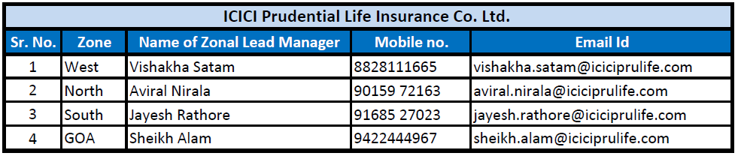
Annuity Quotes:-
https://www.iciciprulife.com/retirement-pension-plans/buy-immediate-annuity-online.html?UID=1160
- Star Union Dai-ichi Life Insurance Co. Ltd
ASP Name:- Star Union Dai-ichi Life Insurance Co. Ltd
Address:- Star Union Dai-ichi Life Ins. Co Ltd, Raghuleela Arcade, 11th Floor, IT Park,Sector 30A, Vashi, Navi Mumbai - 400703, # 022 3954 6300, Toll Free No:1800 200 8833
Contact Details:- 1800 266 8833
Email :- customercare@sudlife.in
Zone/Region wise Contact Details:-
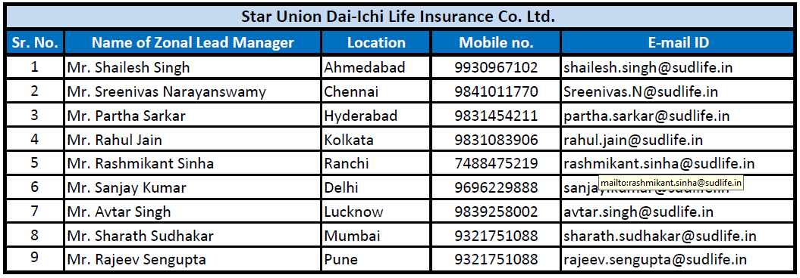
- SBI Life Insurance Co. Ltd
ASP Name:- SBI Life Insurance Co. Ltd (Hindi)
Address:- SBI Life Insurance Co Ltd, New Business Department, Central Processing Centre, Seawoods Grand Central, Tower 2, 8th Level, Plot No. R-1, Sector 40, Seawoods, Nerul Node, Navi Mumbai - 400 706.
Contact Details:- 1800 103 4294
Email :- online.cell@sbilife.co.in
Zone/Region wise Contact Details
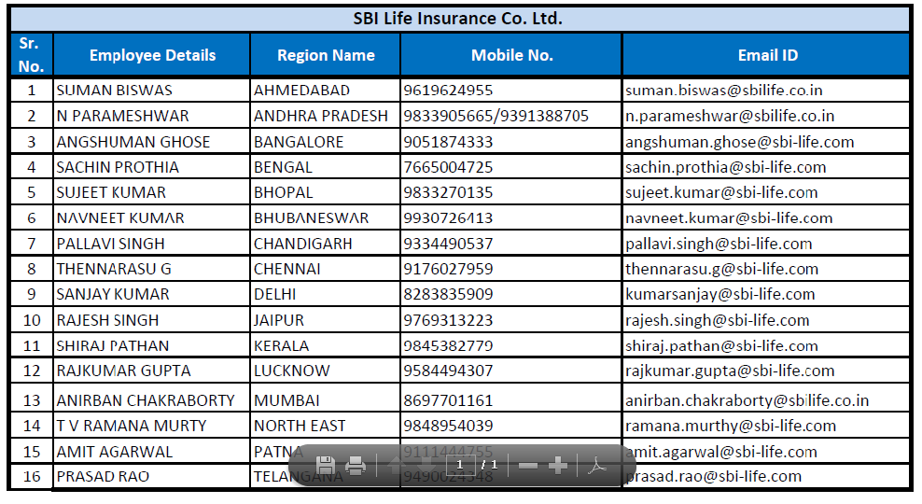
Additional Link:- SBI Life Annuity Plus Application Form
https://agencyonline.sbilife.co.in/genericproposal/annuitynpspropdata.do
Annuity Quotes:- https://custombi.sbilife.co.in/PFRDA/

## For annuity quotes please visit the respective annuity service provider site or refer PFRDA link provided below ##
https://www.pfrda.org.in/index1.cshtml?lsid=1062

